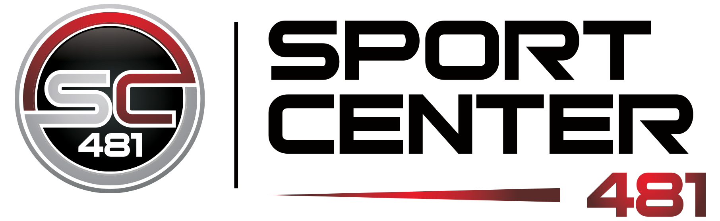
Adult Soccer League
2020 Fall Indoor Registration

Team Name: _______________________________ League (circle): Men’s Women’s

Responsible Party: _______________________________ Phone #: _______________________________

League | # Players on Field | Start Date | Game Times | Dates
Men’s | 7 v 7 | Sun 10/25/2020  Starting times are an estimate. Depending on the number of teams in a division, times may vary. | 5p-8p | 10/25/2020 – 1/10/2020  (No league games on 12/27)
Women’s | 7 v 7 | Sun 10/25/2020  Starting times are an estimate. Depending on the number of teams in a division, times may vary. | 5p-8p | 10/25/2020 – 1/10/2020  (No league games on 12/27)
Email: ______________________________

Sport Center 481 Soccer Leagues:

Ages 18+, no exceptions

Total 11 games (10, plus a playoff)

Games are (2) 25-minute halves played during an allocated hour (clock starts on the hour)

Divisions are limited, we recommend that you register your teams ASAP

Teams may request double header or bye weeks if necessary, please contact Brandon.
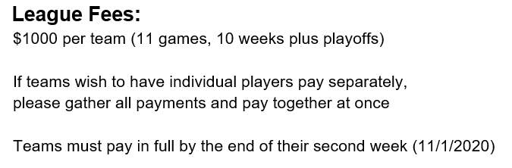
Any questions? Contact Brandon Fascia (see below)

Sport Center 481
6841 Collamer Road, East Syracuse, NY 13057
315-701-1111
www.sportcenter481.com
Brandon Fascia | info@sportcenter481.com

